Target Keyword Cluster: farmlands for sale near Bangalore | managed farmland near Bangalore | Vedic forest science | biodiversity by design | organic farmland projects | farm plots for families
Featured Thumbnail HTML: <img src="importance-of-educating-newer-generation-about-farmlands.jpg" alt="farmlands for sale near Bangalore" />
Secondary Image Alt Tags: alt="managed farmland near Bangalore children" | alt="Vedic forest science Vanatvam" | alt="organic farmland project Karnataka"
Meta Title: Importance of Educating the Newer Generation About Farmlands | Vanatvam
Meta Description: Why the next generation needs a real connection to how food is grown — and how Vanatvam's managed farmland near Bangalore gives children and families that experience, rooted in Vedic forest science.
URL slug: /blog/importance-of-educating-newer-generation-about-farmlands/ (confirm against live site structure)
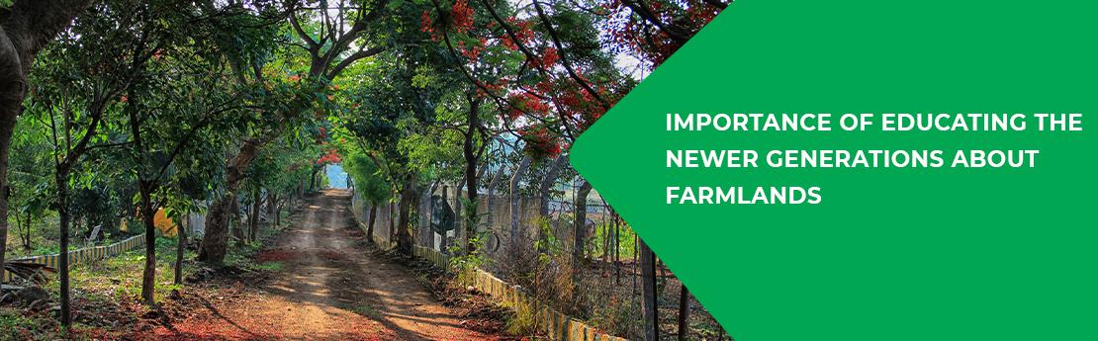

Importance of Educating the Newer Generation About Farmlands
India has long been a land of agriculture. Even today, agriculture and related work remain the livelihood for a large share of India's workforce — the Periodic Labour Force Survey put it at around 45% nationally, and closer to 60% in rural India, as of 2023–24. But India is moving fast toward urbanisation, and many children of farmers no longer want to continue farming. Educating the younger generation about where food comes from isn't a nostalgic idea — it's becoming essential, given the risk of food shortages ahead.
Here is why it matters:

1. A growing population
The United Nations projects the world's population will approach 9.7 billion by 2050. As population grows, so will the demand for food, and we will need more people who understand how to grow it well. The younger generation should be educated about how food is actually grown. Owning farmland and exposing children to farming early equips future generations to manage the growing food requirements ahead.

2. Learning plant science, rooted in tradition
Vanatvam, in partnership with specialist growers and agronomists, is on a mission to revive farmlands [<b><a href="/farm-land-for-sale-near-bangalore/">farmlands</a></b>] by reviving Vedic forest science [<b><a href="/">Vedic forest science</a></b>]. Our aim is to build sustainable farms the natural way, without harmful chemicals — and that means thinking beyond a single crop. A farm planted only with fruit-bearing trees is an incomplete ecosystem; something else has to feed the soil, fix nitrogen, and shelter the pollinators that keep it all alive. This is biodiversity by design [<b><a href="/">biodiversity by design</a></b>], and it gives you and your children a genuine opportunity to learn good farming practice and see, firsthand, how nature is meant to be nurtured.

3. Respect for nature
The new generation will be tomorrow's decision-makers. If they understand how deeply connected humans and nature really are, they'll be better equipped to make sound decisions about nurturing it. It matters that every thoughtful parent exposes their children to farm life. We see ourselves as custodians of the land we develop, not just its developers — and that same sense of custodianship is what we hope children carry forward. By choosing farmlands for sale near Bangalore [<b><a href="/farm-land-for-sale-near-bangalore/">farmlands for sale near Bangalore</a></b>], you give your children that opportunity. A generation exposed to farming grows up with greater respect for the food on their table — and for the land that grew it.

One philosophy, many landscapes
This is the same thinking behind every Vanatvam community — whether it's MadhuVana [<b><a href="/madhuvana/">MadhuVana</a></b>] near Bangalore on the banks of the Cauvery, AnantaVana [<b><a href="/anantavana/">AnantaVana</a></b>] near Kabini, Eeshavana [<b><a href="/eeshavana/">Eeshavana</a></b>] along the Kaveri, or BrindaVana [<b><a href="/brindavana/">BrindaVana</a></b>]'s arid-zone landscape near Pavagada. Each gives children a different hands-on introduction to how food is grown and how land is cared for — so a family can choose the setting that suits them, and still pass on the same lesson.
For more information, check our website: Vanatvam.com.
Want a quote? Email us at: info@vanatvam.com.
Follow us on socials: Facebook, Instagram, X (Twitter), LinkedIn, YouTube.

Frequently Asked Questions

Why is it important to involve children in farming today?
As population and food demand rise, the world will need more people who understand how food is grown. Early exposure to farming also builds a child's respect for food and for the land — something that's harder to teach once they've grown up entirely removed from it.

What makes Vanatvam's approach to farming different?
We build on Vedic forest science and biodiversity by design — mixed-species planting rather than a single crop — and we think of ourselves as custodians of the land, not just its developers. That shapes how we farm, and what children see and learn when they visit.

Does Vanatvam have multiple farm communities?
Yes. MadhuVana sits near Bangalore on the Cauvery, AnantaVana near Kabini, Eeshavana along the Kaveri near Kollegala, and BrindaVana in an arid-zone landscape near Pavagada — each with its own character and its own lessons for a visiting family.
Ready to give the next generation a real connection to the land?
Explore Vanatvam's farm communities [<b><a href="https://vanatvam.com/farm-land-for-sale-near-bangalore/">farmlands for sale near Bangalore</a></b>] on our website | Want a quote? Email us at: info@vanatvam.com
Follow us on socials: Facebook | Instagram | X (Twitter) | LinkedIn | YouTube

